8. Project Demonstration Phase
Objective

To demonstrate the complete working process of the Auto Ticket Classification system and show how Flow Designer automatically classifies and routes support tickets.

Demonstration Activities

- Introduce the project objective.
- Explain the problem with manual ticket classification.
- Explain the proposed automated solution.
- Show the configured Flow Designer workflow.
- Demonstrate the flow trigger.
- Create a sample support ticket.
- Show how the flow processes the ticket.
- Demonstrate the classification condition.
- Show the assigned category.
- Show the assigned support group.
- Verify the updated ticket.
- Explain the final output.

Demonstration Workflow

The demonstration follows the sequence:

Create Ticket → Flow Triggered → Ticket Details Checked → Condition Evaluated → Category Assigned → Support Group Assigned → Ticket Updated

Sample Demonstration

A sample ticket is created with a login/password-related issue.

The Flow Designer detects the new ticket and evaluates the configured conditions. The ticket is then classified under the appropriate category and assigned to the relevant support group.

The same process can be demonstrated using hardware, software, and network-related tickets.

Expected / Produced Output

The demonstration shows a complete working automation in which a newly created ticket is automatically classified and routed without requiring manual classification.

Screenshots

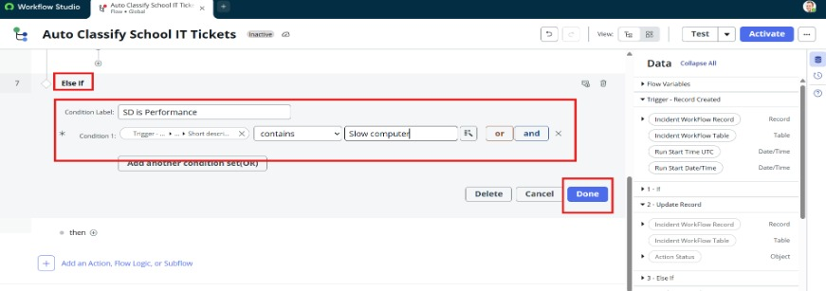
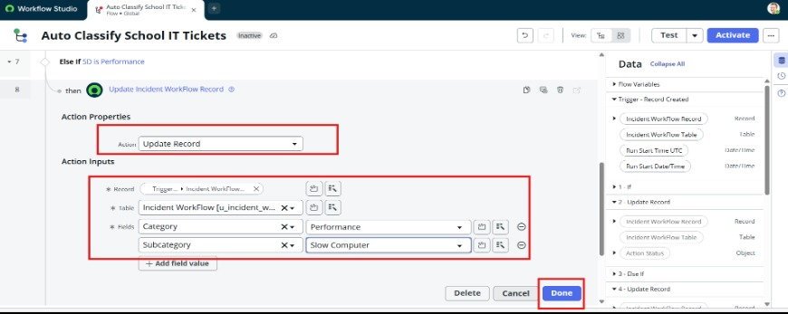

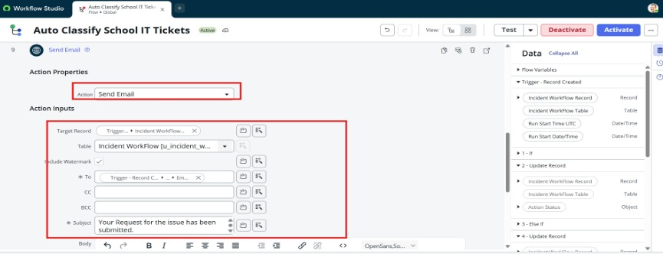

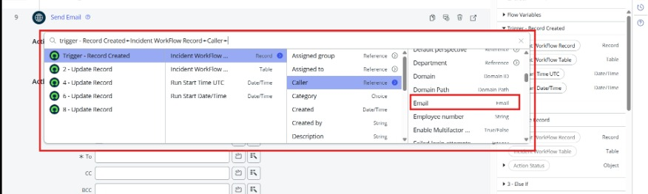
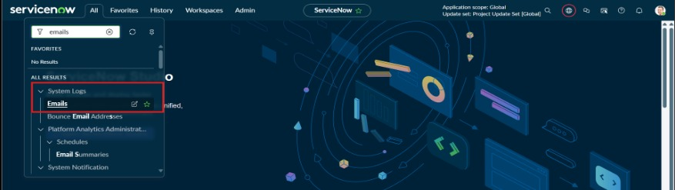

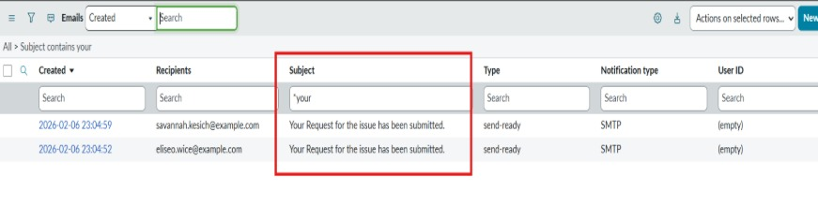
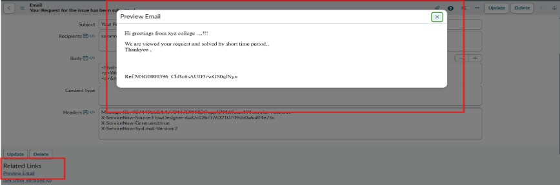

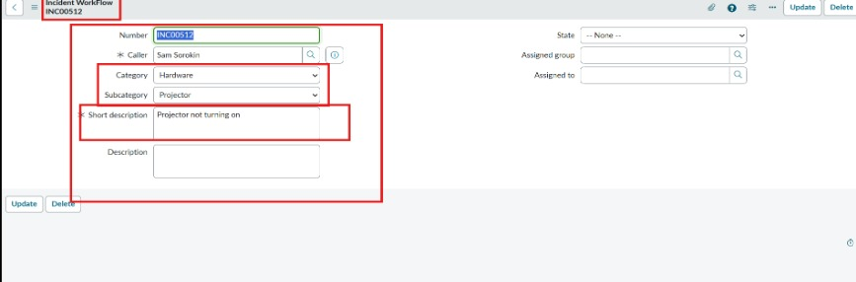
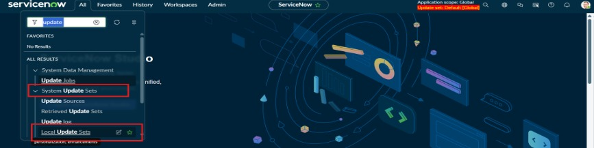

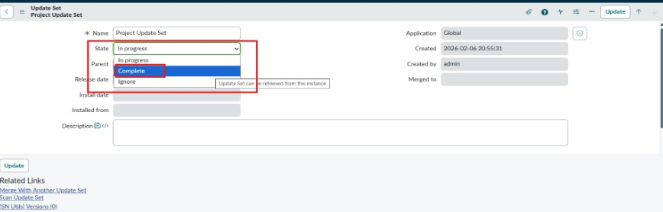

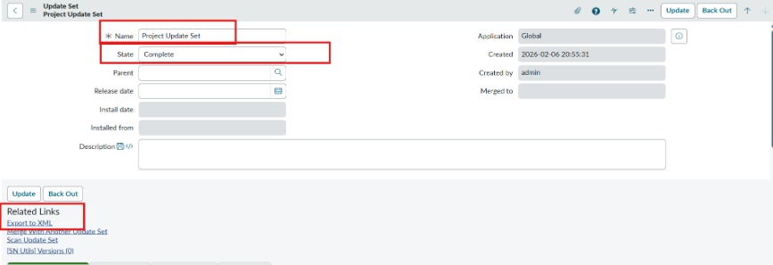

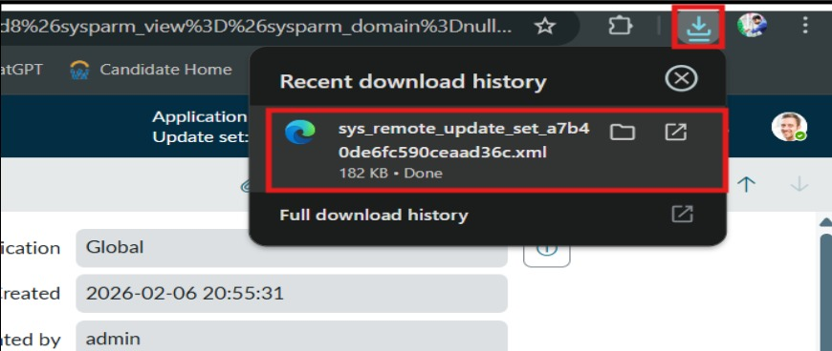

Final Workflow

Ticket Creation → Flow Designer Trigger → Condition Check → Automatic Classification → Category Assignment → Support Group Assignment → Ticket Update → Completion
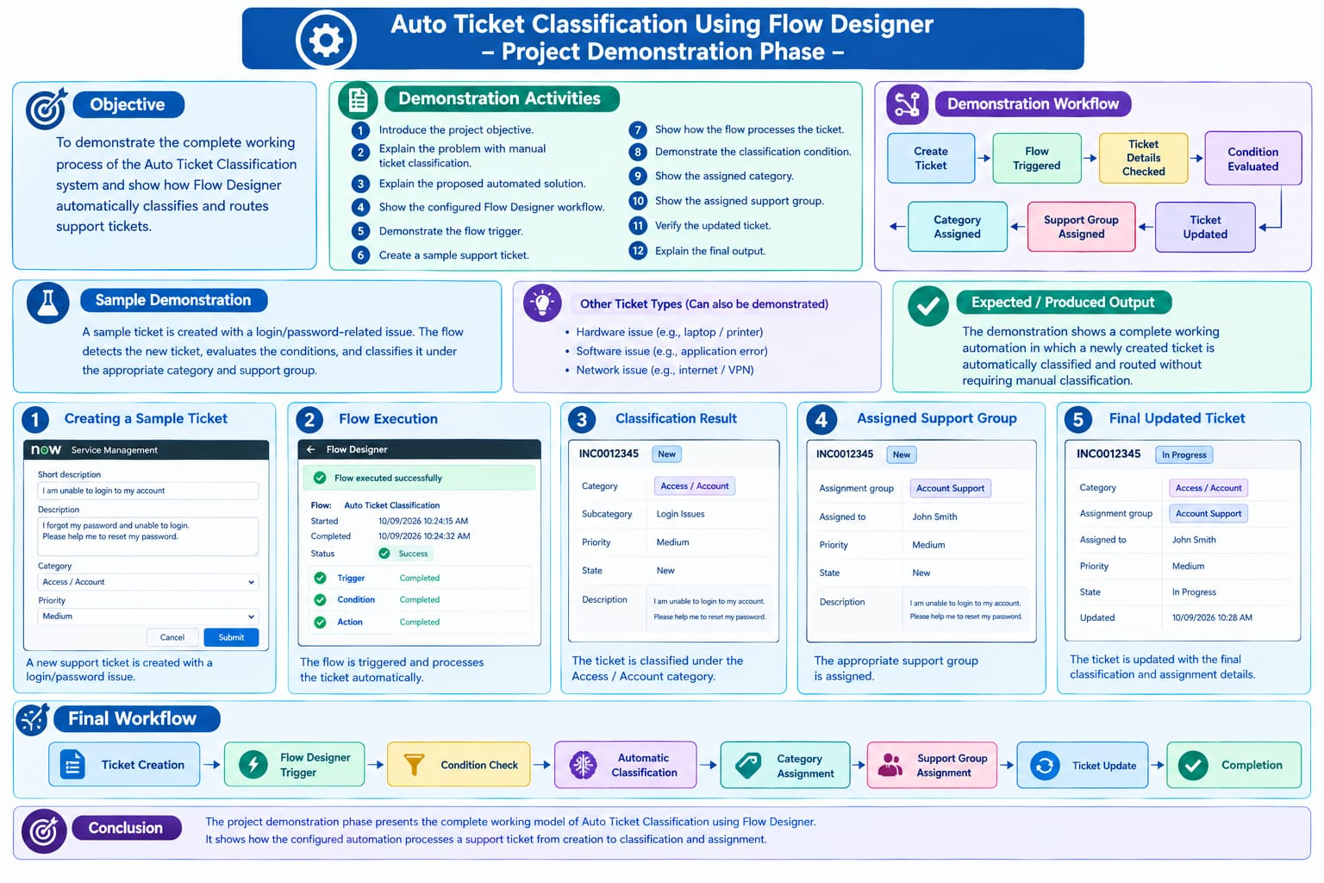
Conclusion

The project demonstration phase presents the complete working model of Auto Ticket Classification using Flow Designer. It shows how the configured automation processes a support ticket from creation to classification and assignment.

